Figure 7.1: Gantt Chart- 7 Feb 2016 - 20 March 2016

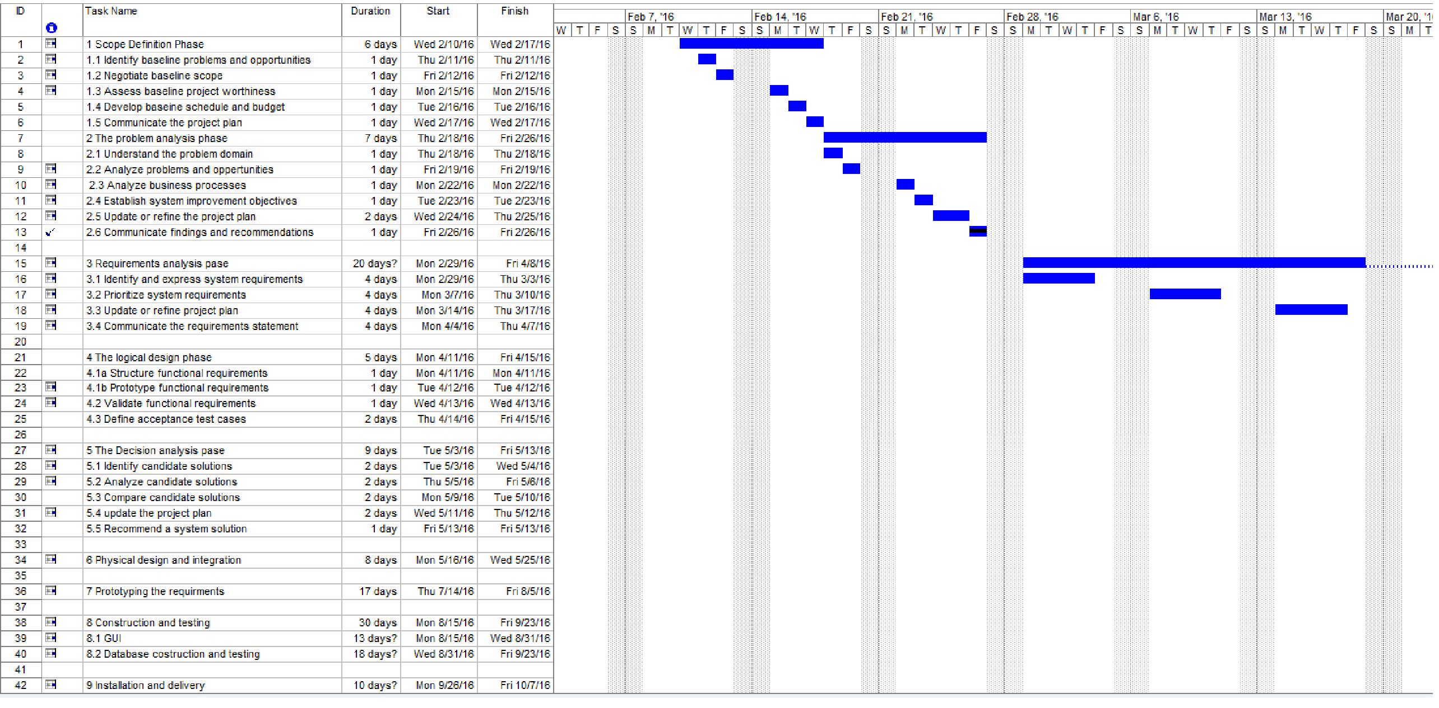

Figure 7.2: Gantt Chart- 20 March 2016 - 5 June 2016

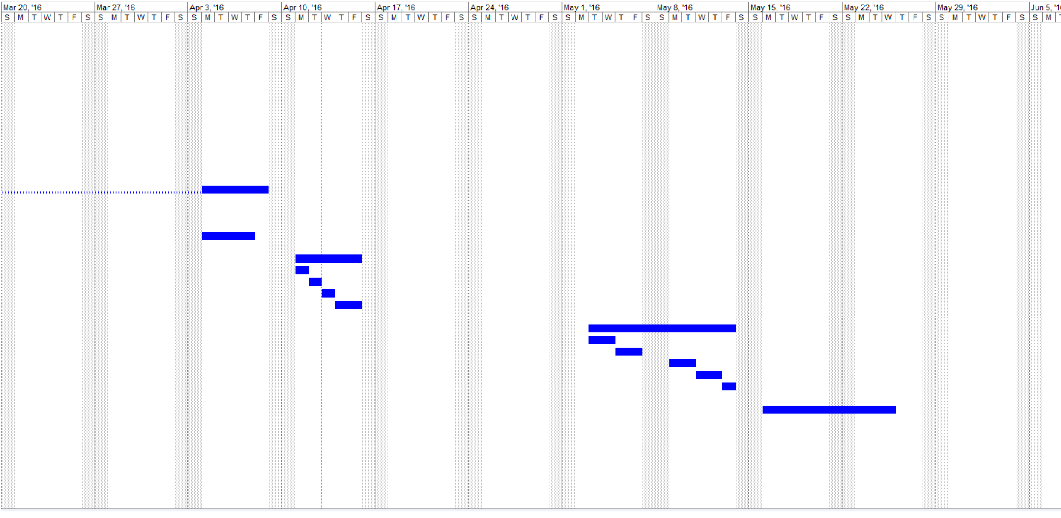

Figure 7.3: Gantt Chart- 5 June 2016 - 21 Aug 2016

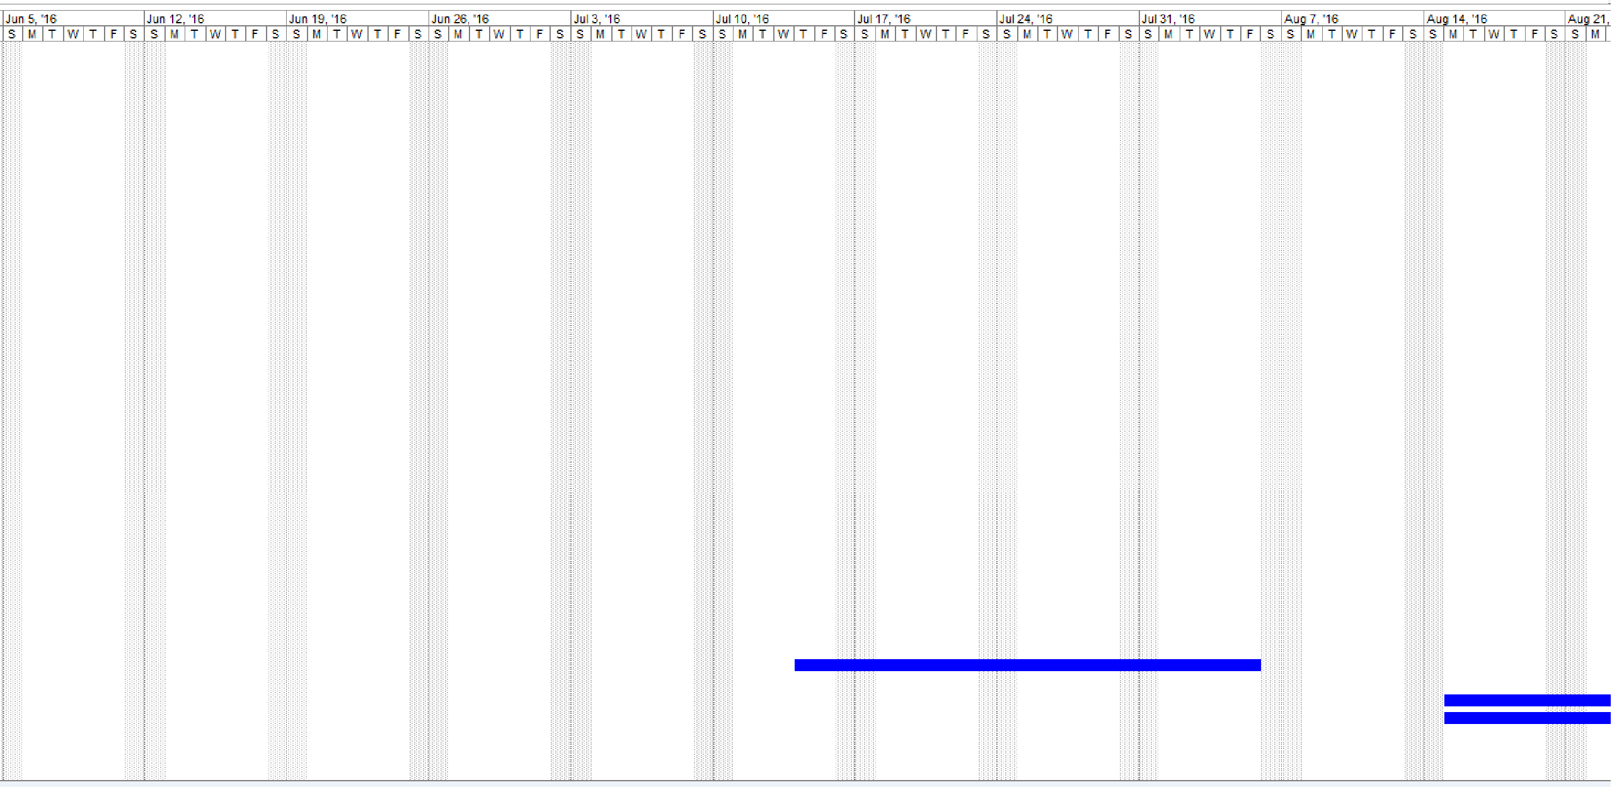

Figure 7.4: Gantt Chart- 21 Aug 2016 - 9 Oct 2016

